**Module – Mernstack – HTML**

**Question : Define HTML. What is the purpose of HTML in web developmen**

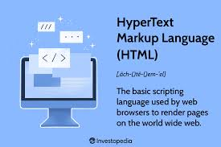

**HTML (HyperText Markup Language)** is the standard markup language used for creating and structuring content on the web. It forms the foundation of every webpage and defines the structure and layout of a web document using a system of elements and tags.

**Purpose of HTML in Web Development:**

1. **Structure Content**: HTML organizes and structures text, images, videos, and other media into a cohesive webpage. For example, headings, paragraphs, and lists are created using specific tags.
2. **Hyperlinking**: It enables the creation of hyperlinks that connect different pages and resources on the web, forming the "web" in World Wide Web.
3. **Semantic Meaning**: HTML provides semantic tags (e.g., <header>, <footer>, <article>) that help define the purpose of content elements, improving accessibility and SEO (Search Engine Optimization).
4. **Integration with Other Technologies**: HTML works seamlessly with CSS (Cascading Style Sheets) for styling and JavaScript for interactivity, allowing developers to create dynamic and visually appealing web applications.
5. **Cross-Platform Support**: HTML is platform-independent and can be rendered by any web browser, making it universally accessible.

**Key HTML Features:**

* **Tags**: Markup tags like <p> for paragraphs or <img> for images define the structure.
* **Attributes**: Add extra information to elements (e.g., <a href="url"> defines a hyperlink).
* **Scalability**: Works for simple static websites and complex web applications alike.

By providing the backbone for webpage content, HTML ensures that web developers can deliver information in a structured, user-friendly manner.

**Question : Explain the difference between the GET and POST methods in form submission. When should each be used?**

**GET** and **POST** are two HTTP methods used for form submission, and they differ primarily in how data is transmitted and their intended use cases.

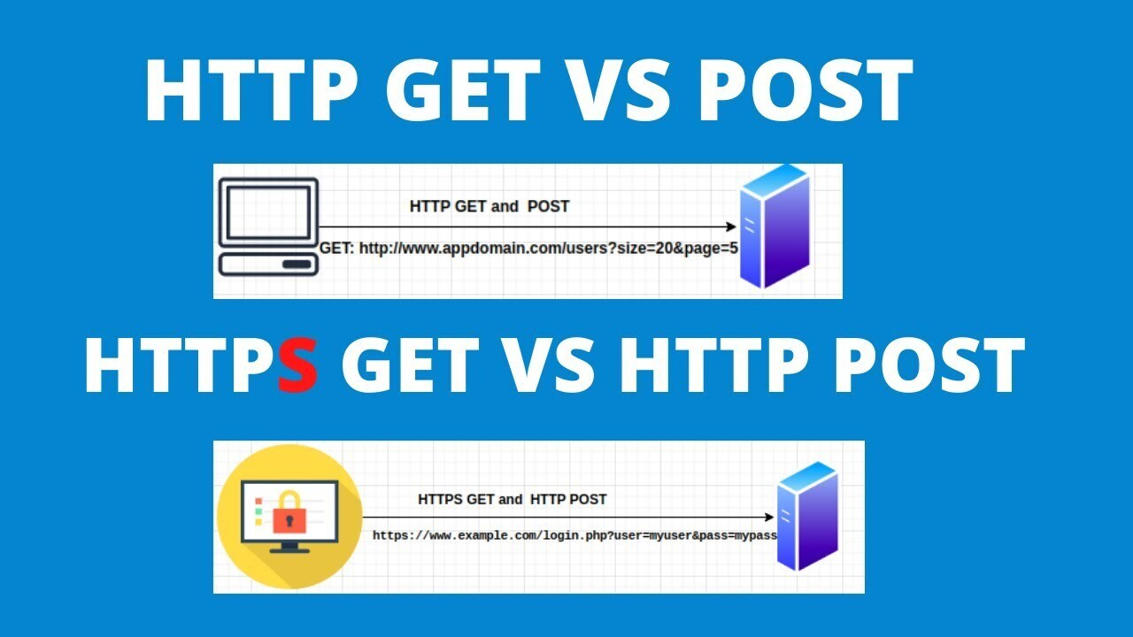

**1. GET Method**

* **Data Transmission**: Appends form data (name-value pairs) to the URL in the query string. For example:

arduino

Coad

http://example.com/form?name=John&age=25

* **Visibility**: The data is visible in the URL and can be bookmarked or shared.
* **Length Limit**: Limited by the URL length (browser-dependent, generally up to 2,048 characters).
* **Idempotency**: GET requests are idempotent, meaning multiple identical requests will have the same effect and should not cause side effects.
* **Caching**: Often cached by browsers, making it faster for repeated requests.

**When to Use GET:**

* For actions that retrieve data without modifying server-side resources (e.g., search queries).
* When data is not sensitive or private.
* For bookmarking or sharing links with parameters.

2. POST Method

* Data Transmission: Sends form data in the request body, not visible in the URL.
* Visibility: Data is hidden from the URL, making it more secure for sensitive information.
* Length Limit: No significant restriction on the amount of data (depends on server configuration).
* Non-Idempotency: POST requests are not idempotent; they can cause server-side changes (e.g., creating or updating data).
* Caching: Not typically cached by browsers.

When to Use POST:

* For actions that modify server-side data (e.g., creating an account, making a purchase).
* When sending sensitive information (e.g., passwords, personal data).
* For large amounts of data or file uploads.

**Question : What is the purpose of the label element in a form, and how does it improve accessibility?**

The <label> element in HTML is used to define labels for input elements in a form. It provides a descriptive text or context for form fields, helping users understand the purpose of each input.

**Purpose of the <label> Element:**

1. **Association with Form Controls**: The <label> element associates descriptive text with a specific input field, such as a text box, checkbox, or radio button. This can be done by:

* Wrapping the input element

HTML

<label>Username: <input type="text" name="username"></label>

* **Using the for attribute** to link to an input's id

**HTML**

**<label for="email">Email Address:</label>**

**<input type="email" id="email" name="email">**

1. **Improved Usability:** Clicking on the label text places the cursor or toggles the associated input field, improving ease of use for mouse users**.**
2. **Enhances Accessibility:**
   * Screen readers use <label> elements to describe input fields to visually impaired users. This ensures that users understand the purpose of the input field.
   * Provides context for input fields that might not have explicit descriptions otherwise.
3. **Consistency**: Creates a clear and consistent way to provide descriptions for form fields, ensuring that the form is intuitive and user-friendly.

**How <label> Improves Accessibility:**

* **Screen Reader Compatibility**: Labels are read out by screen readers when users focus on the corresponding input field.
* **Keyboard Navigation**: Enhances the experience for users navigating forms using a keyboard, as labels clarify which input field is active.
* **Context and Clarity**: For users with cognitive disabilities, descriptive labels provide clear guidance on what to input.

**Question : Explain the basic structure of an HTML document. Identify the mandatory tags and their purposes.**

An HTML (HyperText Markup Language) document serves as the foundation for creating web pages. It defines the structure and content of a web page using a set of elements (tags). Here's an explanation of the basic structure of an HTML document, including the mandatory tags and their purposes

An HTML (HyperText Markup Language) document serves as the foundation for creating web pages. It defines the structure and content of a web page using a set of elements (tags). Here's an explanation of the basic structure of an HTML document, including the mandatory tags and their purposes:

### Basic Structure of an HTML Document

<!DOCTYPE html>

<html>

<head>

<title>Page Title</title>

</head>

<body>

<h1>Welcome to My Website</h1>

<p>This is a paragraph of text.</p>

</body>

</html>

### Mandatory Tags and Their Purposes

1. **<!DOCTYPE html>**:
   * **Purpose**: Declares the document type and version of HTML being used. In this case, it specifies HTML5.
   * **Why Mandatory**: Ensures browsers correctly interpret and render the document.
2. **<html>**:
   * **Purpose**: Encloses the entire HTML document. It acts as the root element.
   * **Why Mandatory**: Provides a container for all the content and structure.
3. **<head>**:
   * **Purpose**: Contains metadata about the document, such as the title, character encoding, linked stylesheets, and scripts.
   * **Why Mandatory**: While the <head> tag itself is mandatory, some of its child elements (like <meta> or <link>) are optional, but it typically includes the document's <title>.
4. **<title>** (inside <head>):
   * **Purpose**: Specifies the title of the document displayed in the browser tab or search engine results.
   * **Why Mandatory**: Every HTML document should have a title for accessibility and SEO purposes.
5. **<body>**:
   * **Purpose**: Contains the main content of the web page that is visible to users, such as text, images, and interactive elements.
   * **Why Mandatory**: It is essential to define what will appear on the web page.

### Summary of Mandatory Tags:

* <!DOCTYPE html>: Defines the HTML version.
* <html>: Root element containing the entire document.
* <head>: Holds metadata.
* <title>: Sets the document's title (within <head>).
* <body>: Contains visible page content.

By following this structure, you can create a valid and functional HTML document that is correctly interpreted by web browsers.

**Question : What is the difference between block-level elements and inline elements in HTML? Provide examples of each**

In HTML, elements are broadly categorized into **block-level elements** and **inline elements** based on their default display behavior and their role in structuring content.

### **Block-Level Elements**

* **Definition**: Block-level elements create a new "block" or section in the document. They start on a new line and take up the full width of their parent container by default.
* **Behavior**:
  + Forces a line break after the element.
  + Typically used for creating structure or layout.
  + Can contain other block-level or inline elements.
* **Examples**:
  + <div>: General-purpose container for grouping content.
  + <p>: Represents a paragraph.
  + <h1> to <h6>: Define headings of different levels.
  + <ul> and <ol>: Unordered and ordered lists.
  + <table>: Represents tabular data.

### **Inline Elements**

* **Definition**: Inline elements do not start on a new line. They occupy only as much width as necessary and are part of the same "line" as surrounding content.
* **Behavior**:
  + Does not force a line break.
  + Typically used for formatting or styling specific parts of the content.
  + Cannot contain block-level elements.
* **Examples**:
  + <span>: General-purpose container for inline content.
  + <a>: Represents a hyperlink.
  + <strong>: Denotes strong importance (usually bold).
  + <em>: Denotes emphasized text (usually italic).
  + <img>: Embeds an image.

**Question : Discuss the role of semantic HTML. Why is it important for accessibility and SEO? Provide examples of semantic elements.**

### **Role of Semantic HTML**

**Semantic HTML** refers to the use of HTML elements that have meaningful names that clearly describe their content and purpose. These elements not only provide structure but also add meaning to the content, making it more accessible to users and search engines.

### **Importance of Semantic HTML**

#### 1. **Accessibility**:

* **Improved Assistive Technology Support**: Semantic elements provide context to assistive technologies like screen readers, helping visually impaired users understand the content more effectively.
  + For example, a <header> tag indicates a page's header section, while a <nav> tag signals a navigation menu.
* **Enhanced Keyboard Navigation**: Semantic elements help users who navigate using keyboards by defining landmarks and regions, making it easier to jump between sections.

#### 2. **SEO (Search Engine Optimization)**:

* **Better Indexing by Search Engines**: Search engines use semantic HTML to understand the structure and relevance of the content.
  + For example, using <article> for blog posts or <section> for distinct content segments helps search engines categorize information.
* **Higher Search Rankings**: Proper semantic tagging can improve ranking as search engines prioritize well-structured and meaningful content.

#### 3. **Code Readability and Maintainability**:

* Semantic HTML makes the code easier to read and understand for developers, enabling quicker updates and debugging.
* It also promotes the use of standardized practices

### **Examples of Semantic Elements**

| **Element** | **Purpose** | **Example Usage** |
| --- | --- | --- |
| <header> | Defines the header of a document or section. | Contains a logo, title, or navigation links. |
| <footer> | Defines the footer of a document or section. | Contact info, copyright, or links. |
| <article> | Represents self-contained content. | A blog post, news article, or forum post. |
| <section> | Groups related content in a document. | A chapter in an article or a theme group. |
| <nav> | Represents navigation links. | Main site menu or internal links. |
| <aside> | Represents content tangentially related. | Sidebars, pull quotes, or related links. |
| <main> | Represents the main content of the document. | Excludes repeated content like headers or sidebars. |
| <figure> | Groups media content with captions. | Images, diagrams, or code snippets with <figcaption>. |
|  |  |  |

Question : Discuss the role of semantic HTML. Why is it important for accessibility and SEO? Provide examples of semantic elements.

### The Role of Semantic HTML

Semantic HTML refers to using HTML elements that have a clear and specific meaning, representing the structure and content of a webpage. These elements not only define the appearance of content but also provide contextual information, making the web more accessible and search-engine-friendly.

### Importance of Semantic HTML

1. **Accessibility**:
   * **Screen Readers**: Semantic elements allow assistive technologies, such as screen readers, to understand the structure of a page better. For example, <header>, <nav>, <main>, and <footer> help screen readers navigate content efficiently.
   * **Keyboard Navigation**: Landmarks provided by semantic elements make keyboard navigation smoother for users who rely on it.
   * **Context Clarity**: Using elements like <article> or <section> informs assistive tools about the purpose of content, making it easier for users to comprehend.
2. **SEO (Search Engine Optimization)**:
   * **Search Engine Crawlers**: Search engines prioritize pages with semantic markup because it helps them interpret the content more accurately.
   * **Rich Snippets**: Proper use of semantic elements increases the likelihood of content being presented as rich snippets in search results, improving visibility.
   * **Improved Ranking**: Pages that are semantically structured tend to rank better since they align with web standards and enhance user experience.

### Examples of Semantic Elements

1. **Structural Elements**:
   * <header>: Represents introductory content or navigation links for a page or section.
   * <main>: Contains the main content of a document, ensuring focus on what matters most.
   * <footer>: Provides footer content like copyright, links, or contact details.
2. **Content-Specific Elements**:
   * <article>: Represents self-contained content, like a blog post or news article.
   * <section>: Groups related content under a thematic heading.
   * <aside>: Denotes complementary content, such as sidebars or advertisements.
   * <nav>: Indicates navigation links, like a menu or table of contents.
3. **Text Elements**:
   * <h1>, <h2>, <h3>: Define headings, providing a clear hierarchy for content structure.
   * <figure> and <figcaption>: Used for images or illustrations with captions.
   * <time>: Represents a date or time value, useful for events or schedules.

### Example: Semantic vs. Non-Semantic HTML

#### Non-Semantic HTML:

<div id="header">Welcome to My Website</div>

<div id="content">Here is some content about my site.</div>

<div id="footer">© 2025 My Website</div>

Semantic HTML:

<header>

<h1>Welcome to My Website</h1>

</header>

<main>

<p>Here is some content about my site.</p>

</main>

<footer>

<p>© 2025 My Website</p>

</footer>

### Benefits in Practice

Using semantic HTML ensures inclusivity, improves SEO rankings, and enhances maintainability. Adopting these standards aligns with the best practices for creating web content that is user-friendly, accessible, and efficient for search engines to index.